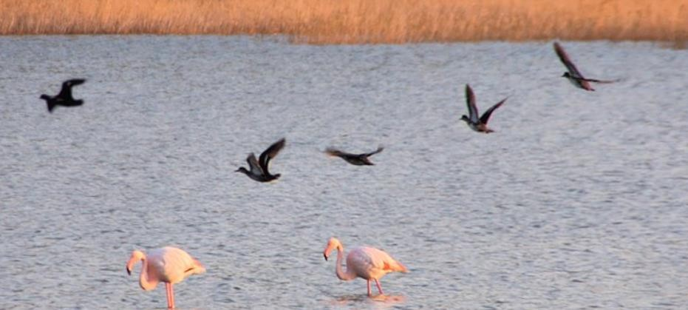
SAMOS SALTWORKS WETLAND

DESCRIBE WHAT YOU SEE AROUND YOU.

DRAW OR ADD A PANORAMIC PHOTO OF THE AREA.
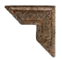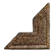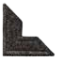

SOIL

What is the terrain of the wetland like?


- Take a soil sample from some point in the wetland and write a short
description.

- Compare your observations with those of the other groups.

WATER

- Take a water sample and write a short
description.

- Measure the pH and the salinity of the water.

- Compare your measurements with those of the other groups.

PLANTS
DRAW ONE OF THE PLANTS YOU SAW IN THE AREA.

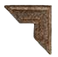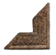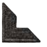

Use the SEEK app to identify it.



Name:
Scientific name:
Color:
Size:
Shape:
Where in the wetland did you see it:
What else do you know about it:

ANIMALS
DRAW ONE OF THE ANIMALS YOU SAW IN THE AREA.

DRAW CAREFULLY

Name:
Scientific name:
Color:
Size:
Shape:
Where in the wetland did you see it:
What else do you know about it:

FLORA, FAUNA, AND ABIOTIC FACTORS OF THE SALTWORKS


AT THE SALTWORKS…
- Use the SEEK app and take photos of the wetland’s plants and animals.

AT SCHOOL…
- Print the photos. Collect information about the animals and plants you saw.
Work in groups and prepare a poster about the wetland.

- Find information about what salinity and acidification mean and how they affect the stability and biodiversity of aquatic ecosystems.

IN THE LAB…

- ACIDIFICATION AND AQUATIC ECOSYSTEMS
A) PRODUCING CARBON DIOXIDE IN THE LAB
NaHCO₃ + CH₃COOH → CH₃COONa+ H₂O +CO₂ ↑
B) RECORDING CHANGES IN THE pH OF SEAWATER AND FRESHWATER
BY BUBBLING CARBON DIOXIDE THROUGH THEM (measurement with a pH meter and/or an indicator)
C) EFFECTS OF ACIDIFICATION ON SHELLS / SHELLFISH

